SOFTWARE ARCHITECTURE DOCUMENT
Online Quiz System
Team 73
Software Engineering Project
PES University
September 2026

Team | 73
Project | Online Quiz System
Member 1 | Nakshathira — PES2UG24AM096
Member 2 | Poojitha.P — PES2UG24AM112
Member 3 | Sharanya.N — PES2UG24AM150
Member 4 | Rahul Rajkumar.S — PES2UG24AM128

Document Control
Document Title | Software Architecture Document
Project | Online Quiz System
Team | 73

Table of Contents
1. Introduction
2. Architecture Overview
3. Architectural Style and 3-Tier Structure
4. System Modules
5. Frontend / Presentation Layer
6. Backend / Application Layer
7. Database / Data Layer
8. Interfaces
9. Data Flow
10. Deployment View
11. Security Architecture
12. Scalability, Reliability and Quality Attributes
13. Architecture Diagram
14. Design Constraints and Assumptions
15. Traceability to SRS Requirements
16. Conclusion

1. Introduction
This Software Architecture Document describes the high-level architecture of the Online Quiz System for Team 73. The architecture is derived from the team's Software Requirements Specification (SRS). The system is a standalone web-based application that allows users to select quiz categories, attempt timed multiple-choice quizzes, receive feedback, view scores, and compare performance through a leaderboard. Administrators manage quiz questions, categories, and quiz content.

1.1 Purpose
The purpose of this document is to define the major software components, their responsibilities, interfaces, data flow, deployment structure, security considerations, and quality considerations for the Online Quiz System.

1.2 Architectural Scope
- Web-based client accessed through modern desktop and mobile web browsers.
- Application server responsible for request processing, quiz logic, scoring, and result processing.
- Structured database for users, quiz categories, quizzes, questions, answers, scores, and leaderboard data.
- User and Administrator as the two main user classes.
- HTTP/HTTPS for client-server communication, with HTTPS preferred for protecting credentials and sensitive data.

2. Architecture Overview
The Online Quiz System follows a three-tier architecture consisting of a Presentation Layer, Application/Business Layer, and Data Layer. This separation keeps the user interface, application logic, and persistent data responsibilities distinct.
Layer | Main Responsibility | Major Components
Presentation | Provides the web interface and collects user/admin actions. | Login/Registration, Home, Category, Quiz, Result, Feedback, Leaderboard, Admin UI
Application / Business | Processes requests and applies quiz and business rules. | Authentication, Quiz Management, Timer, Answer Recording, Scoring, Feedback, Results, Leaderboard
Data | Persists and retrieves system data. | Users, Categories, Quizzes, Questions, Answers, Results, Scores, Leaderboard Records

3. Architectural Style and 3-Tier Structure

3.1 Presentation Layer
The Presentation Layer is the browser-based user interface. It provides screens for authentication, category selection, quiz participation, results, feedback, leaderboard viewing, and administrator content management.

3.2 Application / Business Layer
The Application Layer runs on the application server. It processes user requests, executes quiz logic, records responses, evaluates answers, calculates scores, handles result processing, and supports leaderboard operations. It also enforces administrator authorization for management functions.

3.3 Data Layer
The Data Layer is a structured database that stores and retrieves user, quiz, question, answer, result, and leaderboard information. The application server mediates database access.

4. System Modules
Module | Primary Responsibility | Primary Actor
Authentication | Registration/login and account access control. | User / Administrator
Quiz Category | Display and select available categories. | User
Quiz Management | Create/manage quizzes and their content. | Administrator
Question Management | Add, update, and delete quiz questions. | Administrator
Quiz Attempt & Timer | Start quizzes, display questions, enforce time limit. | User
Answer Recording | Record the user's selected answers. | User
Scoring | Evaluate submitted answers and calculate the score. | System
Feedback | Provide feedback on user answers. | System
Result Management | Store and display completed quiz results. | User / System
Leaderboard | Maintain and display rankings based on quiz performance. | User / System

5. Frontend / Presentation Layer
The frontend provides the following main interfaces identified in the SRS:
- Login/Registration screen for user authentication.
- Home screen for accessing quiz categories.
- Quiz screen displaying questions, answer options, and remaining time.
- Result screen displaying score and feedback.
- Leaderboard screen displaying user rankings.
- Administrative interface for managing quiz questions and categories.
- Clear navigation, readable content, consistent button placement, and suitable messages for invalid inputs or completed actions.

6. Backend / Application Layer
The backend is organized around the following logical services/components:
- Authentication and Authorization Service — verifies access and restricts administrative functions.
- Category and Quiz Service — retrieves categories and quizzes and supports quiz selection.
- Question Service — retrieves quiz questions and supports administrator question management.
- Quiz Attempt Service — starts quiz sessions, manages question presentation, and enforces the time limit.
- Answer Service — records selected answers during the quiz.
- Scoring Service — compares submitted answers with correct answers and calculates the final score.
- Feedback Service — provides feedback on submitted answers.
- Result Service — stores and retrieves completed quiz results.
- Leaderboard Service — retrieves relevant scores and displays rankings based on recorded performance.

7. Database / Data Layer
The architecture uses a structured database. The following logical data groups are required by the SRS:
Data Group | Purpose
Users | User details and authentication-related information.
Quiz Categories | Categories available for quiz selection.
Quizzes | Quiz definitions associated with categories.
Questions | Multiple-choice questions belonging to quizzes.
Answers | Answer options and correct-answer information.
Quiz Results | Completed quiz scores and related result information.
Leaderboard Records | Recorded performance used to display rankings.

8. Interfaces

8.1 User Interface
The browser provides the interface through which users and administrators interact with the system.

8.2 Application Interface
The web interface communicates with the application server using standard web communication protocols. HTTP/HTTPS is used for client-server communication, with HTTPS preferred for protecting credentials and sensitive data.

8.3 Database Interface
The application server communicates with the database to store and retrieve users, quizzes, questions, answers, scores, results, and leaderboard information. Communication with the database is handled through the application server.

9. Data Flow
- The user accesses the Online Quiz System through a web browser.
- The user authenticates and accesses the home interface.
- The system retrieves and displays available quiz categories.
- The user selects a category and an available quiz.
- The system starts the quiz and the timer.
- The system displays multiple-choice questions and answer options.
- The user selects answers and the application records the responses.
- The quiz ends when the user submits it or the specified time limit expires.
- The application evaluates the submitted answers and calculates the score.
- The system provides feedback and displays the final score.
- The result is stored in the database.
- The leaderboard retrieves relevant recorded scores and displays rankings.

10. Deployment View
The deployment view consists of a user device running a modern web browser, an application server, and a database. The application server processes requests and acts as the intermediary between the browser and database.
Deployment Node | Hosted Components | Role
User Device | Modern Web Browser | Provides access to the web interface on desktop or mobile devices.
Application Server | Online Quiz Application / Business Services | Processes requests, quiz logic, scoring, result processing, and management operations.
Database Server | Structured Quiz System Database | Stores and retrieves persistent user, quiz, question, answer, result, and leaderboard data.

11. Security Architecture
- Authentication is required for access to user accounts.
- Administrative functions are restricted to authorized administrators.
- HTTPS is preferred to protect credentials and other sensitive information during transmission.
- User and quiz data are handled through the application server rather than direct browser-to-database access.
- The system should prevent unauthorized modification of quiz questions and categories.
- Expired quiz sessions should not incorrectly accept additional responses.

12. Scalability, Reliability and Quality Attributes

12.1 Scalability
- Separation of presentation, business logic, and data responsibilities supports modular growth.
- The application server provides a central processing layer between clients and the database.
- The structured database supports reliable storage and retrieval as quiz content and result records increase.
- The architecture can support increasing browser clients without requiring the presentation layer to access the database directly.

12.2 Reliability
- Quiz responses and scores should be recorded accurately.
- Quiz results should be retained for later performance and leaderboard display.
- The system should prevent loss of submitted answers and results during normal operation.
- Expired quiz sessions should be handled without accepting invalid additional responses.

12.3 Software Quality Attributes
- Usability — clear and simple quiz interface.
- Reliability — accurate scoring and result storage.
- Maintainability — modular system components.
- Testability — clearly defined and verifiable requirements.
- Responsiveness — support for commonly used desktop and mobile web browsers.

13. Architecture Diagram
The following diagram presents the proposed 3-tier/component architecture for the Online Quiz System. It shows the actors, presentation layer, application/business services, data layer, and major communication paths.
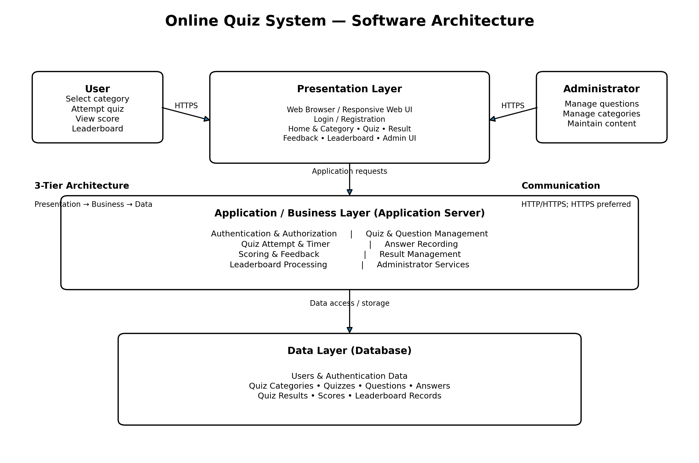
Figure 1. High-level 3-tier software architecture for the Online Quiz System.

14. Design Constraints and Assumptions
- The system is a web-based application.
- Users are assumed to have a compatible web browser and a stable internet connection.
- The application depends on the availability of the application server and database.
- Quiz questions and categories are maintained by the administrator.
- A structured database is required for storing and retrieving quiz information.
- The system must support timed quizzes and accurate scoring and leaderboard results.
- The SRS does not specify a particular programming language, frontend framework, backend framework, or database product; therefore, this architecture remains technology-independent.

15. Traceability to SRS Requirements
SRS Area | Architecture Element | Architectural Support
REQ-01 to REQ-03 | Category / Quiz Services | Presentation and application layers retrieve and present categories and associated quizzes.
REQ-04 to REQ-08 | Quiz Attempt & Timer | Application layer manages question presentation, answer recording, timer, and quiz completion.
REQ-09 to REQ-12 | Scoring & Feedback | Business layer evaluates answers, provides feedback, calculates and displays scores.
REQ-13 to REQ-15 | Result & Leaderboard Services | Data layer stores results; leaderboard service retrieves performance and rankings.
REQ-16 to REQ-19 | Administrator Services | Authorized administrator interface and application services manage questions and categories.
REQ-20 to REQ-21 | Application/Data Layers | Separation of processing and storage supports timely request handling and accurate recording.
REQ-22 to REQ-24 | Security Architecture | Authentication, administrator authorization, and HTTPS support account and data protection.

16. Conclusion
The proposed architecture provides a clear separation between the web interface, application/business logic, and persistent data. It supports the Online Quiz System functions defined in the SRS, including category selection, timed quiz attempts, answer recording, scoring, feedback, result storage, leaderboard display, and administrator management of quiz content. The architecture also addresses the stated security, reliability, maintainability, testability, and browser compatibility requirements while remaining independent of a specific implementation technology.

Source Basis
This architecture document is based on Team 73's Software Requirements Specification for the Online Quiz System, including its stated product scope, user classes, software components, interfaces, system features, nonfunctional requirements, business rules, database requirements, and compatibility requirements.

